**DAILY ONLINE ACTIVITIES SUMMARY**

|  |  |  |  |  |  |
| --- | --- | --- | --- | --- | --- |
| **Date:** | **11/06/2020** | | | | |
| **Name of the Faculty** | **Shilpa** | | | | |
| **No. of Students Allotted for monitoring** | | | | **19** | |
| **Progress** | | | | **Good** | |
| **Whether collected report from all the allotted students** | | | | **14 submitted.** | |
| **Online Test Summary** | | | | | |
| **Subject** | |  | | | |
| **Semester** | |  | | **Duration** |  |
| **No. of students Taken** | | |  | **Passing %** |  |
| **Certification Course Summary** | | | | | |
| **Course** | 1. **Workshop on Machine Learning using Python** 2. **Workshop on Technical Document Preparation using Latex** 3. **National Level online FDP on PERL Scripting .** | | | | |
| **Certificate Provider** | 1. **NMAMIT, Nitte** 2. **Dr. S &S. S Ghandhy Government Engineering College, Surat.** 3. **Lords Institute of Engineering and Technology, Hyderabad.** | | | **Duration** | **4 days** |
| **Coding Challenges** | | | | | |
| **Problem Statement: -.Write a Java Program to Segregate Even and Odd numbers** | | | | | |
| **Status: - 63** | | | | | |
| **Uploaded the report in Github** | | | | **YES** | |
| **If yes Repository name** | | | | <https://github.com/orgs/alvas-education-foundation/teams/2nd-year> | |
| **Uploaded the report in slack** | | | | **YES** | |

**Coding Challenge Summary**

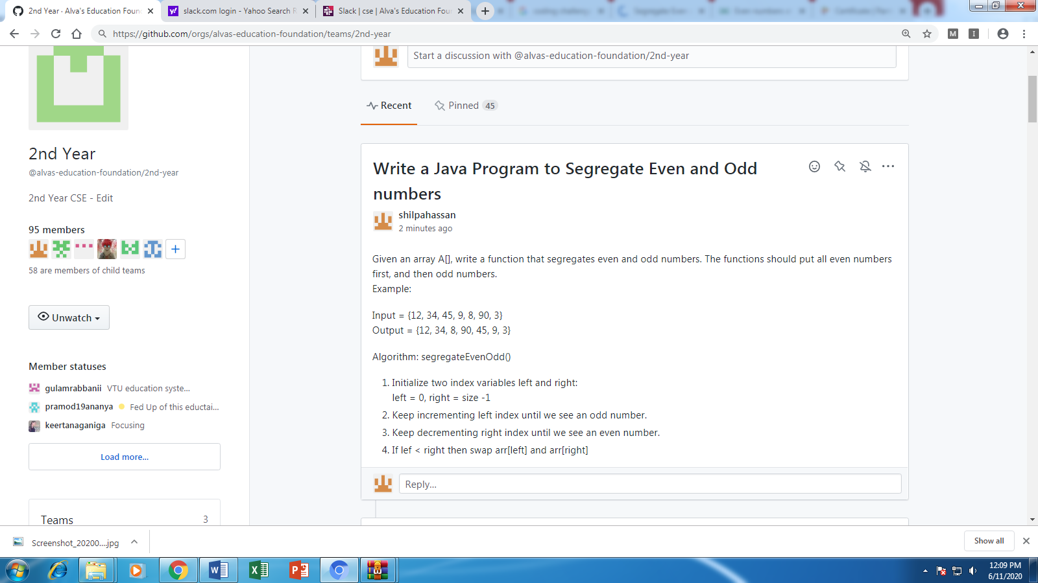

**Certification/webinar Course Summary**

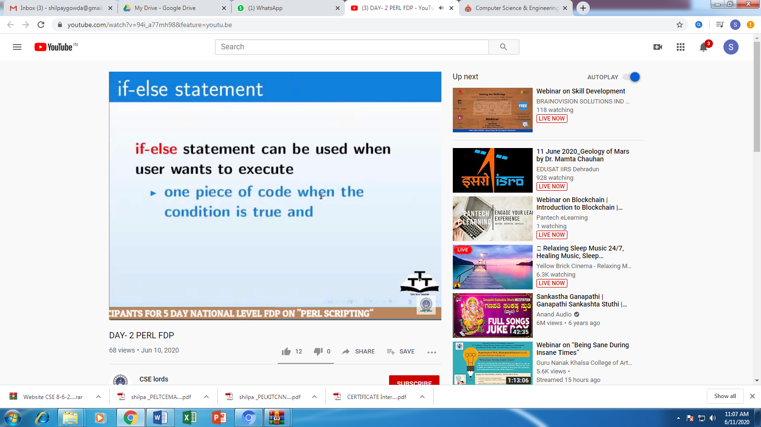

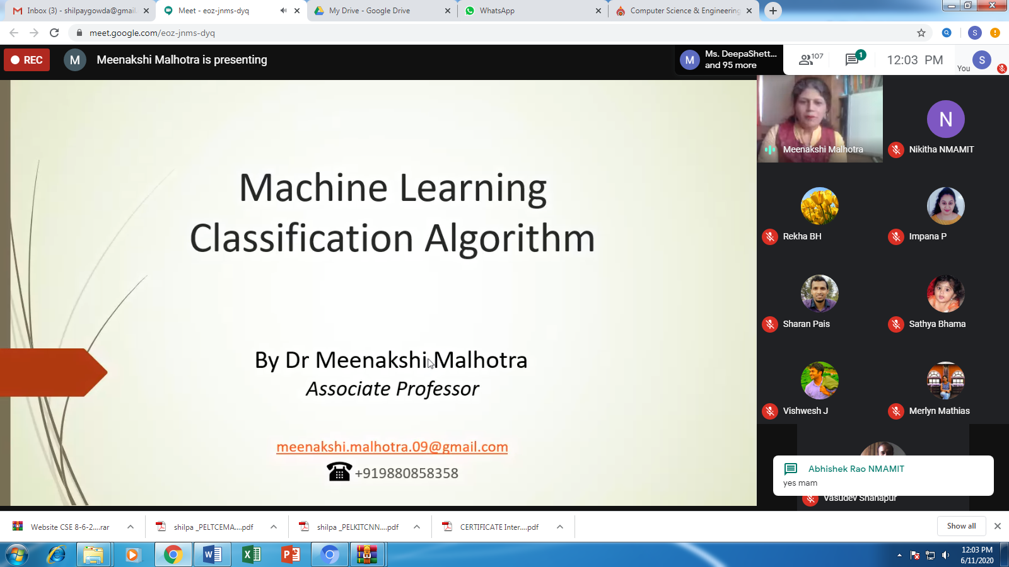

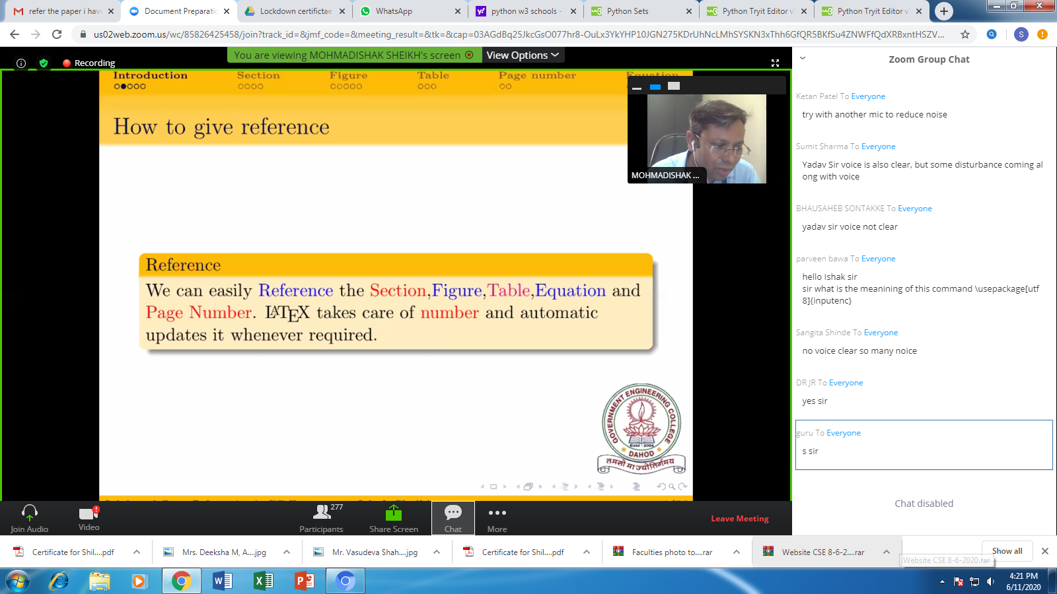

**Students Report:**

